Day49 - Challenge08 - Jenkins Challenge

Connect to the Jenkins EC2 instance
The EC2 instance used for this Jenkins challenge:
Instance name: Jenkins01
Instance ID: i-06e73f51d8c4c03ed
Public IP: 13.204.76.8
Private IP: 172.31.10.28
Username: ec2-user
Region: ap-south-1
Public IP can change after stopping and starting the instance, so confirm it in the EC2 console before connecting.
Windows Git Bash
Step 1: Start the instance
Open:
AWS Console
→ EC2
→ Instances
→ Jenkins01
If stopped:
Instance state
→ Start instance
Wait until:
Instance state: Running
Status checks: 2/2 checks passed
Step 2: Copy the current public IP
From the instance summary, copy:
Public IPv4 address
Previously it was:
13.204.76.8
Step 3: Open the key-pair folder
Open Git Bash and go to the directory containing your .pem key:
cd /c/Users/YOUR_WINDOWS_USERNAME/Downloads
Check the key:
ls *.pem
Step 4: Set key permissions
Replace your-key.pem with the actual filename:
chmod 400 your-key.pem
Step 5: Connect using SSH
ssh -i your-key.pem ec2-user@13.204.76.8
If prompted:
Are you sure you want to continue connecting?
Enter:
yes
Successful connection looks like:
[ec2-user@ip-172-31-10-28 ~]$
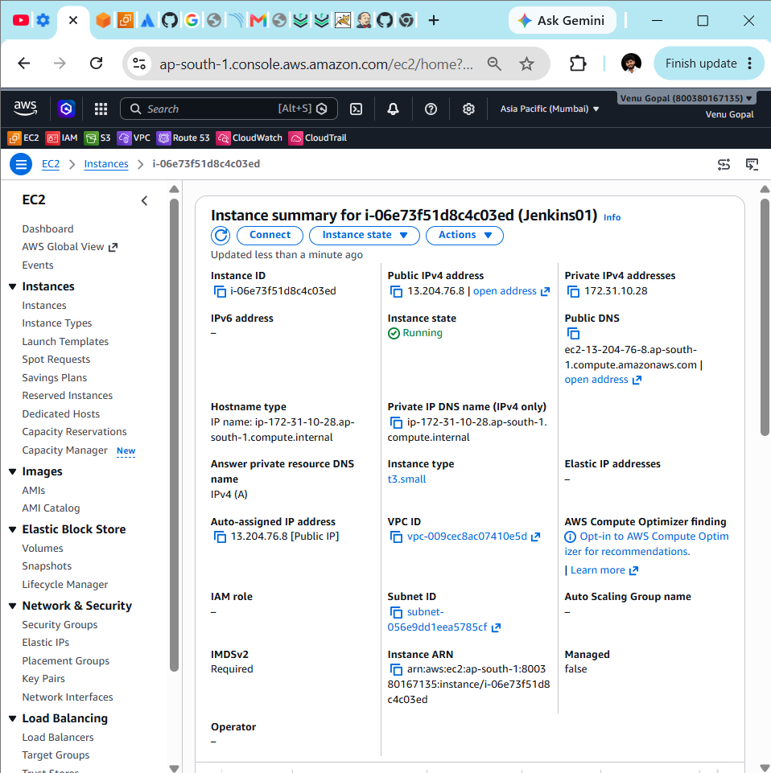
Pipeline jobs
We will create:
- 02-Hiring-App-Declarative
- 03-Hiring-App-Scripted
- 04-Hiring-App-Multi-Stage
- 05-Hiring-App-Parallel
Each pipeline will implement:
Git Clone
→ SonarQube Analysis
→ Maven Build
→ Nexus Upload
→ Tomcat Deployment
→ Slack Notification
Existing credentials
Do not create new credentials.
Service | Credential ID
SonarQube | sonarqube-token
Nexus | nexus-hiring-credentials
Tomcat | tomcat-deploy-credentials
Slack | slack-token
The repository is public, so GitHub credentials are not needed:
https://github.com/betawins/hiring-app.git
Task 1: Declarative Pipeline
Step 1: Create the job
From the Jenkins dashboard:
New Item
Enter the job name:
02-Hiring-App-Declarative
Select:
Pipeline
Click:
OK
Step 2: General settings
On the configuration page:
- Enable Discard old builds.
- Click Advanced under Build Discarder if necessary.
- Set:
Days to keep builds: 7
Max # of builds to keep: 10
Do not enable these yet:
This project is parameterized
GitHub project
Build Triggers
We will define parameters directly inside the pipeline code.
Step 3: Pipeline section
Scroll down to Pipeline.
Select:
Definition: Pipeline script
Keep:
Sandbox: Enabled
I’ll give you the corrected script using:
sonarqube-token
nexus-hiring-credentials
tomcat-deploy-credentials
Step 4: Paste the corrected Declarative Pipeline
Paste the following code into the Pipeline script box:
pipeline {
agent any

parameters {
choice(
name: 'DEPLOY_ENV',
choices: ['dev', 'qa', 'prod'],
description: 'Select deployment environment'
)

booleanParam(
name: 'RUN_SONAR',
defaultValue: true,
description: 'Run SonarQube analysis'
)
}

environment {
GIT_URL = 'https://github.com/betawins/hiring-app.git'
GIT_BRANCH = 'main'

SONAR_URL = 'http://172.31.0.163:9000'
SONAR_PROJECT = 'hiring-app-declarative'

WAR_FILE = 'target/hiring.war'

NEXUS_URL = 'http://localhost:8082'
NEXUS_REPO = 'hiring-releases'
NEXUS_GROUP = 'com/betawins/hiring'

TOMCAT_URL = 'http://localhost:8080'
TOMCAT_CONTEXT = 'hiring'
}

options {
timestamps()
disableConcurrentBuilds()

buildDiscarder(
logRotator(
daysToKeepStr: '7',
numToKeepStr: '10'
)
)
}

stages {
stage('Workspace Cleanup') {
steps {
deleteDir()
}
}

stage('Git Clone') {
steps {
git branch: "${GIT_BRANCH}",
url: "${GIT_URL}"
}
}

stage('Maven Compilation') {
steps {
sh '''
mvn clean compile
'''
}
}

stage('SonarQube Analysis') {
when {
expression {
return params.RUN_SONAR
}
}

steps {
withCredentials([
string(
credentialsId: 'sonarqube-token',
variable: 'SONAR_TOKEN'
)
]) {
sh '''
mvn org.sonarsource.scanner.maven:sonar-maven-plugin:5.7.0.6970:sonar \
-Dsonar.projectKey="$SONAR_PROJECT" \
-Dsonar.projectName="$SONAR_PROJECT" \
-Dsonar.host.url="$SONAR_URL" \
-Dsonar.token="$SONAR_TOKEN"
'''
}
}
}

stage('Maven Package') {
steps {
sh '''
mvn package -DskipTests

echo "Checking generated WAR file..."
test -f "$WAR_FILE"
ls -lh "$WAR_FILE"
'''
}
}

stage('Archive Artifact') {
steps {
archiveArtifacts(
artifacts: 'target/hiring.war',
fingerprint: true
)
}
}

stage('Upload to Nexus') {
steps {
withCredentials([
usernamePassword(
credentialsId: 'nexus-hiring-credentials',
usernameVariable: 'NEXUS_USER',
passwordVariable: 'NEXUS_PASSWORD'
)
]) {
sh '''
ARTIFACT_VERSION="1.0.${BUILD_NUMBER}"
NEXUS_PATH="$NEXUS_GROUP/$ARTIFACT_VERSION/hiring-$ARTIFACT_VERSION.war"

echo "Uploading hiring-$ARTIFACT_VERSION.war to Nexus..."

curl --fail --show-error \
--connect-timeout 10 \
--max-time 60 \
--user "$NEXUS_USER:$NEXUS_PASSWORD" \
--upload-file "$WAR_FILE" \
"$NEXUS_URL/repository/$NEXUS_REPO/$NEXUS_PATH"

echo "Nexus upload completed."
echo "Artifact version: $ARTIFACT_VERSION"
'''
}
}
}

stage('Deploy to Tomcat') {
steps {
withCredentials([
usernamePassword(
credentialsId: 'tomcat-deploy-credentials',
usernameVariable: 'TOMCAT_USER',
passwordVariable: 'TOMCAT_PASSWORD'
)
]) {
sh '''
echo "Deploying hiring.war to Tomcat..."

curl --fail --show-error \
--connect-timeout 10 \
--max-time 60 \
--user "$TOMCAT_USER:$TOMCAT_PASSWORD" \
--upload-file "$WAR_FILE" \
"$TOMCAT_URL/manager/text/deploy?path=/$TOMCAT_CONTEXT&update=true"

echo "Tomcat deployment command completed."
'''
}
}
}

stage('Verify Deployment') {
steps {
withCredentials([
usernamePassword(
credentialsId: 'tomcat-deploy-credentials',
usernameVariable: 'TOMCAT_USER',
passwordVariable: 'TOMCAT_PASSWORD'
)
]) {
retry(5) {
sleep time: 5, unit: 'SECONDS'

sh '''
echo "Checking Tomcat deployment status..."

curl --fail --silent --show-error \
--connect-timeout 10 \
--max-time 30 \
--user "$TOMCAT_USER:$TOMCAT_PASSWORD" \
"$TOMCAT_URL/manager/text/list" \
| grep "^/$TOMCAT_CONTEXT:running:"
'''
}
}
}
}
}

post {
success {
slackSend(
color: 'good',
message: """SUCCESS: ${env.JOB_NAME} #${env.BUILD_NUMBER}
Environment: ${params.DEPLOY_ENV}
Application: hiring
Build URL: ${env.BUILD_URL}"""
)
}

failure {
slackSend(
color: 'danger',
message: """FAILED: ${env.JOB_NAME} #${env.BUILD_NUMBER}
Environment: ${params.DEPLOY_ENV}
Failed stage: Check Jenkins console output
Console: ${env.BUILD_URL}console"""
)
}

unstable {
slackSend(
color: 'warning',
message: """UNSTABLE: ${env.JOB_NAME} #${env.BUILD_NUMBER}
Environment: ${params.DEPLOY_ENV}
Console: ${env.BUILD_URL}console"""
)
}

always {
echo "Pipeline result: ${currentBuild.currentResult}"
deleteDir()
}
}
}
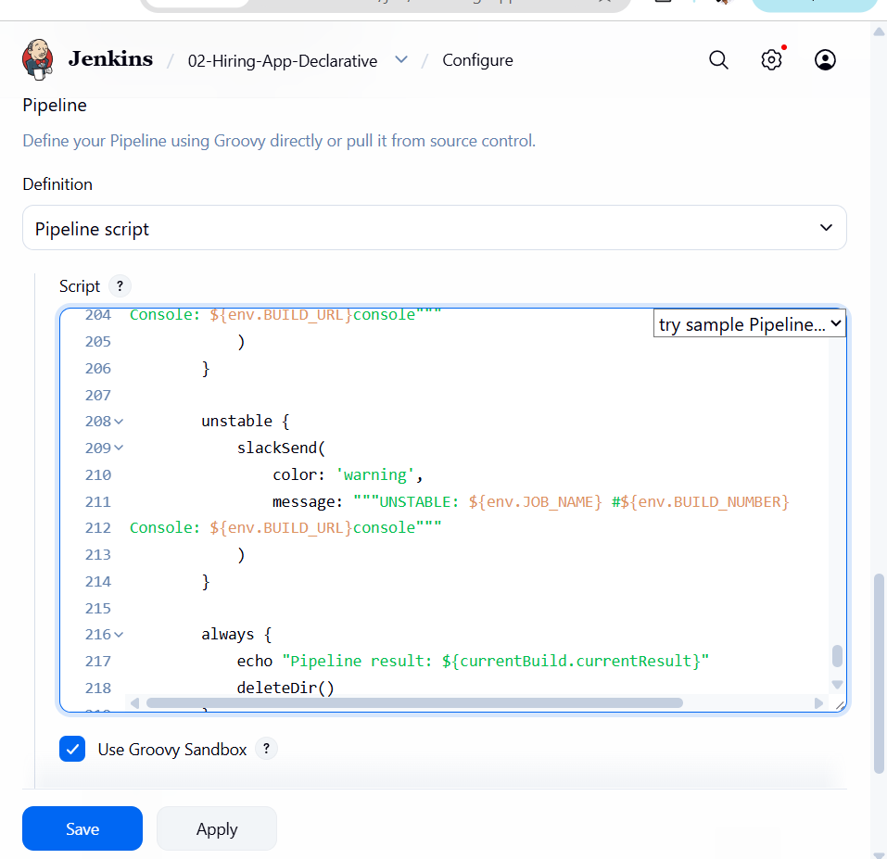
Step 5: Confirm the service addresses
Keep these values in the pipeline exactly as shown:
SONAR_URL = 'http://172.31.0.163:9000'
NEXUS_URL = 'http://localhost:8082'
TOMCAT_URL = 'http://localhost:8080'
Reason:
- Jenkins EC2 private IP: 172.31.10.28
- Nexus runs on Jenkins01 port 8082
- Tomcat container runs on Jenkins01 port 8080
- SonarQube runs on another EC2 server at 172.31.0.163:9000
Do not put the public IP 13.204.76.8 inside the pipeline service URLs.
Step 6: Verify all services
Connect to Jenkins01:
ssh -i your-key.pem ec2-user@13.204.76.8
6.1 Check SonarQube
curl http://172.31.0.163:9000/api/system/status
Expected:
{"version":"...","status":"UP"}
6.2 Check Docker containers
docker ps
Confirm containers are running with these port mappings:
0.0.0.0:8082 → Nexus
0.0.0.0:8080 → Tomcat
If the containers are stopped, check all containers:
docker ps -a
Start them using their actual container names:
docker start nexus
docker start hiring-tomcat
If your Nexus container has a different name, use the name shown by docker ps -a.
6.3 Check Nexus
curl -s -o /dev/null -w "Nexus HTTP status: %{http_code}\n" \
http:// 13.204.76.8:8082
An HTTP status such as 200, 302, or 303 confirms Nexus is responding.
6.4 Check Tomcat
curl -u jenkins-deployer \
http:// 13.204.76.8:8080/manager/text/list
Enter the Tomcat password when prompted.
Expected output includes:
OK - Listed applications for virtual host [localhost]
/:running
/manager:running
Step 7: Save the pipeline
Return to the Jenkins Pipeline configuration page.
Confirm:
Definition: Pipeline script
Use Groovy Sandbox: Checked
Click:
Save
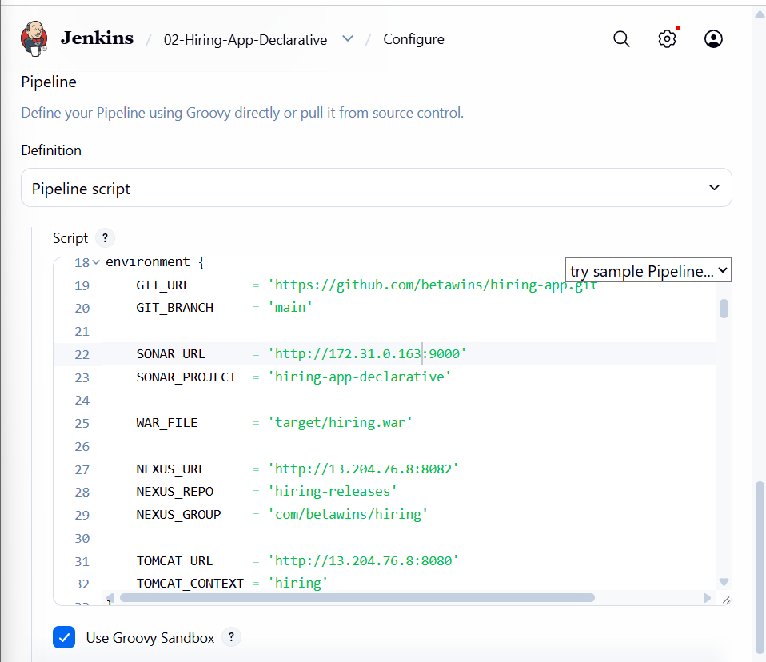
Step 8: Save the pipeline
At the bottom of the Jenkins configuration page, click:
Save
Do not click Apply repeatedly; Save is sufficient.
Step 9: Start the first build
On the job page:
02-Hiring-App-Declarative
→ Build Now
If Build with Parameters already appears, use:
DEPLOY_ENV: dev
RUN_SONAR: checked
→ Build
Step 10: Monitor the build
Open:
Build History
→ #1
→ Console Output
Expected initial stages:
Workspace Cleanup
Git Clone
Maven Compilation
SonarQube Analysis
Maven Package
Archive Artifact
Nexus Upload
Tomcat Deployment
Verify Deployment
Post Actions
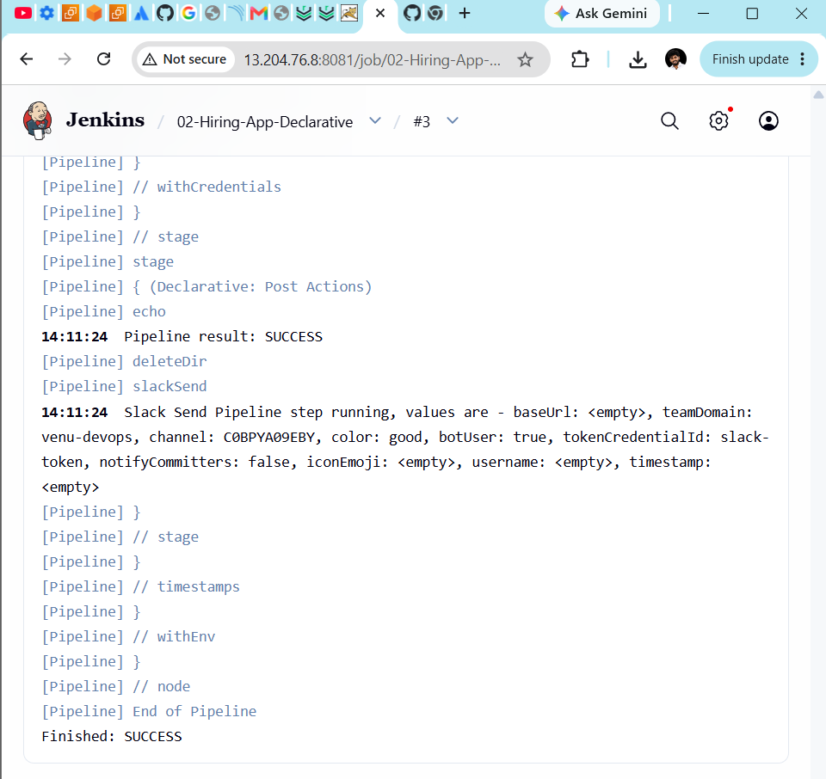

Task 2: Scripted Pipeline Job
The CI/CD stages remain the same, but we will use Scripted Pipeline syntax:
- Declarative starts with pipeline { }
- Scripted starts with node { }
- Scripted Pipeline uses Groovy control structures such as try, catch, finally, and if
Step 1: Create the job
From the Jenkins dashboard:
New Item
Enter:
03-Hiring-App-Scripted
Select:
Pipeline
Click OK.
Step 2: General configuration
Enable:
Discard old builds
Set:
Days to keep builds: 7
Max # of builds to keep: 10
You do not need to select This project is parameterized. The script creates the parameters.
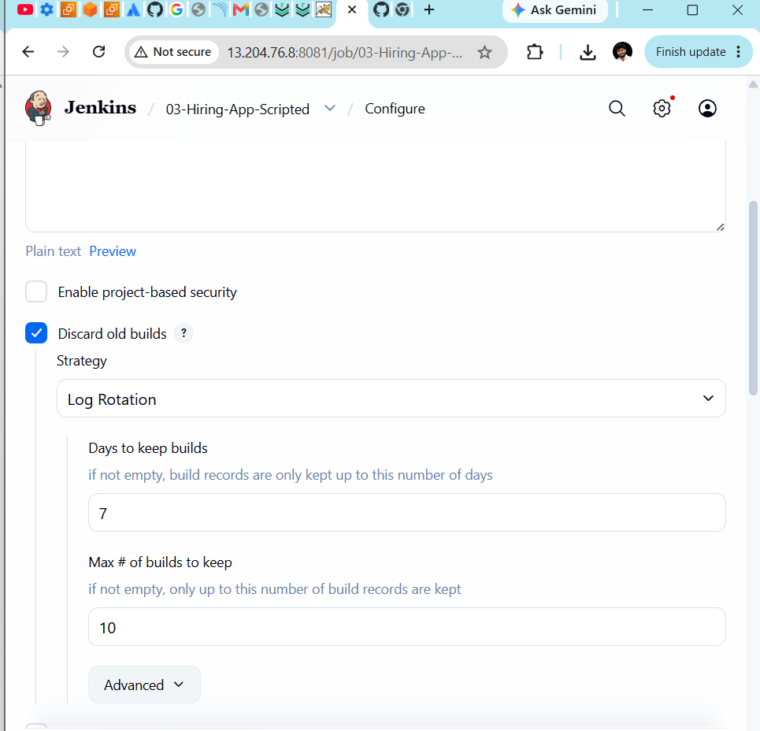
Step 3: Pipeline configuration
Scroll to Pipeline and select:
Definition: Pipeline script
Use Groovy Sandbox: Checked
Step 4: Paste the complete Scripted Pipeline
Paste this entire code into the Pipeline script box:
properties([
curl --fail --silent --show-error \
--connect-timeout 10 \
--max-time 30 \
--user "$TOMCAT_USER:$TOMCAT_PASSWORD" \
"$TOMCAT_URL/manager/text/list" \
| grep "^/$TOMCAT_CONTEXT:running:"
'''
}
}
}
}

currentBuild.result = 'SUCCESS'

slackSend(
color: 'good',
message: """SUCCESS: ${env.JOB_NAME} #${env.BUILD_NUMBER}
Pipeline type: Scripted
Environment: ${deployEnv}
Application: hiring
Build URL: ${env.BUILD_URL}"""
)
} catch (Exception error) {
currentBuild.result = 'FAILURE'

echo "Pipeline failed: ${error.getMessage()}"

slackSend(
color: 'danger',
message: """FAILED: ${env.JOB_NAME} #${env.BUILD_NUMBER}
Pipeline type: Scripted
Environment: ${deployEnv}
Console: ${env.BUILD_URL}console"""
)

throw error
} finally {
echo "Final pipeline result: ${currentBuild.currentResult}"
deleteDir()
}
}
Step 5: Save the job
Click:
Save
Step 6: Run the first build
For the first run, Jenkins may show:
Build Now
Click it once so Jenkins registers the parameters defined by properties().
After that, the job should display:
Build with Parameters
Step 7: Run the parameterized build
Select:
DEPLOY_ENV: dev
RUN_SONAR: checked
Click Build.
Step 8: Monitor the stages
Open:
Build History
→ Latest build
→ Console Output
Expected order:
Workspace Cleanup
Git Clone
Maven Compilation
SonarQube Analysis
Maven Package
Archive Artifact
Upload to Nexus
Deploy to Tomcat
Verify Deployment
Expected final result:
Finished: SUCCESS
The Scripted Pipeline demonstrates:
node
stage
def variables
if/else
try/catch/finally
withEnv
withCredentials
retry
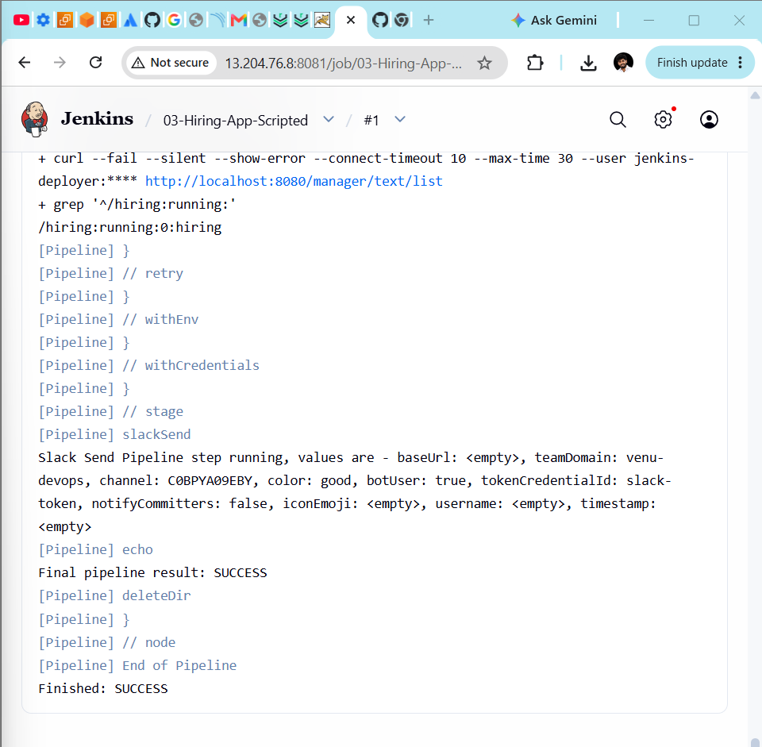

Task 3: Multi-Stage Pipeline Job
This job demonstrates splitting CI/CD work into clearly separated stages:
Initialize → Checkout → Validate → Compile → SonarQube
→ Package → Archive → Nexus → Approval → Tomcat → Verify → Slack
Step 1: Create the job
From the Jenkins dashboard:
New Item
Enter:
04-Hiring-App-Multi-Stage
Select:
Pipeline
Click OK.
Step 2: Configure build history
Enable:
Discard old builds
Set:
Days to keep builds: 7
Max # of builds to keep: 10
Do not enable This project is parameterized because parameters will be defined in the script.
Step 3: Configure the Pipeline section
Scroll to Pipeline.
Select:
Definition: Pipeline script
Use Groovy Sandbox: Checked
Step 4: Paste the complete script
pipeline {
}
}
}

post {
success {
slackSend(
color: 'good',
message: """SUCCESS: ${env.JOB_NAME} #${env.BUILD_NUMBER}
Pipeline type: Multi-Stage
Environment: ${params.DEPLOY_ENV}
SonarQube: ${params.RUN_SONAR}
Deployed: ${params.DEPLOY_APPLICATION}
Build URL: ${env.BUILD_URL}"""
)
}

failure {
slackSend(
color: 'danger',
message: """FAILED: ${env.JOB_NAME} #${env.BUILD_NUMBER}
Pipeline type: Multi-Stage
Environment: ${params.DEPLOY_ENV}
Console: ${env.BUILD_URL}console"""
)
}

aborted {
slackSend(
color: 'warning',
message: """ABORTED: ${env.JOB_NAME} #${env.BUILD_NUMBER}
Pipeline type: Multi-Stage
Environment: ${params.DEPLOY_ENV}
Build URL: ${env.BUILD_URL}"""
)
}

always {
echo "Final pipeline result: ${currentBuild.currentResult}"
deleteDir()
}
}
}
Step 5: Save the job
Click:
Save
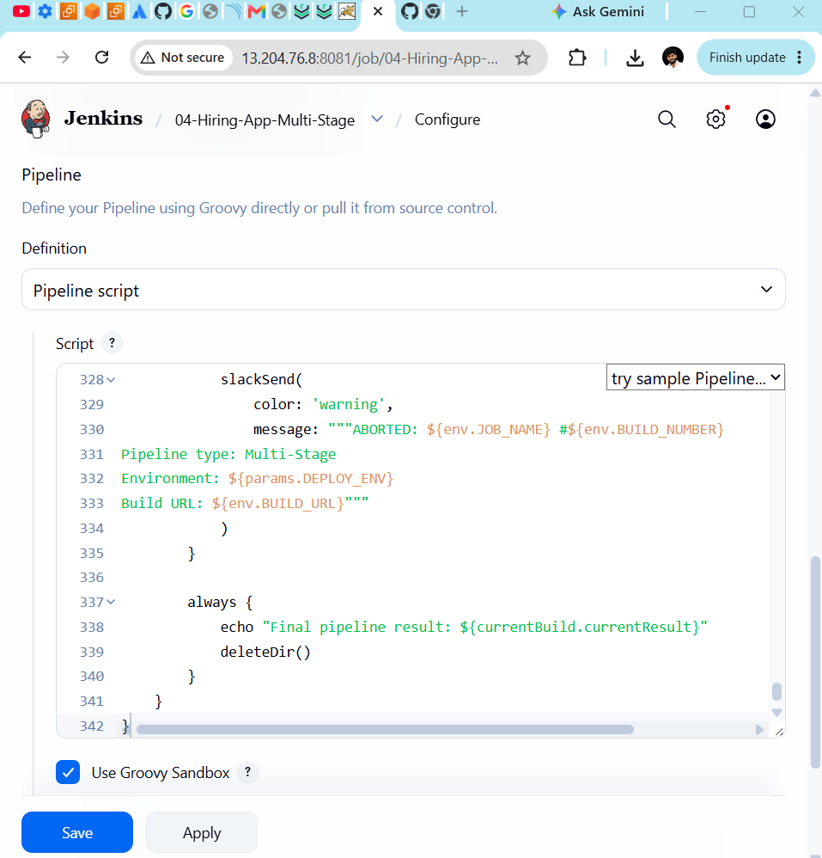
Step 6: Run the first build
If Jenkins shows Build Now, click it once to register the parameters.
Afterward, use:
Build with Parameters
For the practice build, select:
DEPLOY_ENV: dev
RUN_SONAR: checked
DEPLOY_APPLICATION: checked
Do not select prod for the first test. A production build will pause at the Production Approval stage and wait for manual approval.
Step 7: Monitor the build
Open:
Build History
→ Latest build
→ Console Output
Expected stages:
Initialize
Workspace Cleanup
Checkout Source Code
Validate Project
Maven Compilation
SonarQube Analysis
Maven Package
Validate Artifact
Archive Artifact
Upload to Nexus
Production Approval — skipped for dev
Deploy to Tomcat
Verify Deployment
Pipeline Summary
Post Actions
Expected result:
Finished: SUCCESS
The production approval stage should display:
Stage skipped due to when conditional
That is expected when DEPLOY_ENV is dev or qa.
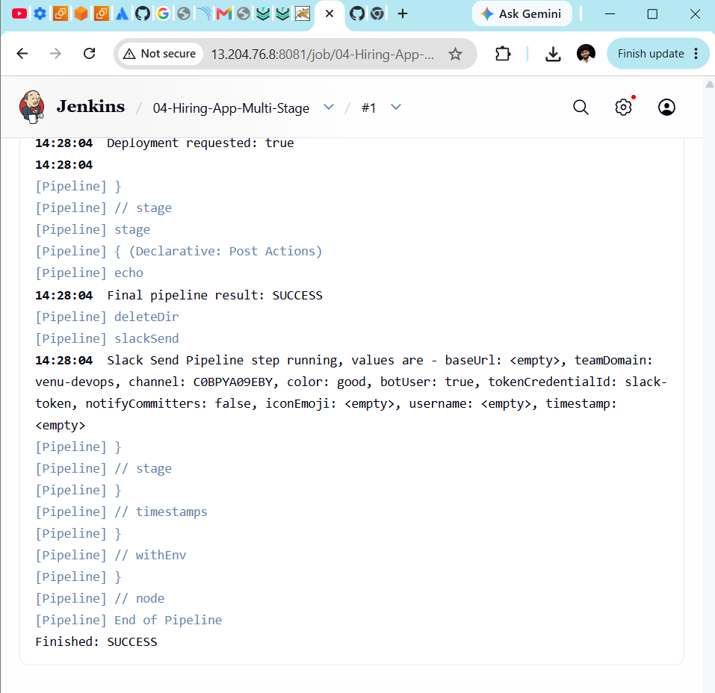

Task 4: Parallel Stage Pipeline
This pipeline runs independent quality checks simultaneously:
┌─ SonarQube Analysis ──────┐
Checkout → Compile ──────┼─ Project Validation ─────┼─ Package
└─ Service Health Checks ───┘
After the parallel stages:
Package → Archive → Nexus → Tomcat → Verify → Slack
Step 1: Create the job
From the Jenkins dashboard:
New Item
Enter:
05-Hiring-App-Parallel
Select:
Pipeline
Click OK.
Step 2: Configure build retention
Enable:
Discard old builds
Set:
Days to keep builds: 7
Max # of builds to keep: 10
Do not enable This project is parameterized. The script creates the parameters.
Step 3: Configure Pipeline
Scroll to Pipeline and select:
Definition: Pipeline script
Use Groovy Sandbox: Checked
Step 4: Paste the complete script
pipeline {

Job: ${env.JOB_NAME}
Build: ${env.BUILD_NUMBER}
Environment: ${params.DEPLOY_ENV}
Artifact: ${env.WAR_FILE}
SonarQube: ${params.RUN_SONAR}
Deployed: ${params.DEPLOY_APPLICATION}
"""
}
}
}

post {
success {
slackSend(
color: 'good',
message: """SUCCESS: ${env.JOB_NAME} #${env.BUILD_NUMBER}
Pipeline type: Parallel
Environment: ${params.DEPLOY_ENV}
SonarQube: ${params.RUN_SONAR}
Deployed: ${params.DEPLOY_APPLICATION}
Build URL: ${env.BUILD_URL}"""
)
}

failure {
slackSend(
color: 'danger',
message: """FAILED: ${env.JOB_NAME} #${env.BUILD_NUMBER}
Pipeline type: Parallel
Environment: ${params.DEPLOY_ENV}
Console: ${env.BUILD_URL}console"""
)
}

aborted {
slackSend(
color: 'warning',
message: """ABORTED: ${env.JOB_NAME} #${env.BUILD_NUMBER}
Pipeline type: Parallel
Environment: ${params.DEPLOY_ENV}
Build URL: ${env.BUILD_URL}"""
)
}

always {
echo "Final pipeline result: ${currentBuild.currentResult}"
deleteDir()
}
}
}
Step 5: Save the job
Click:
Save
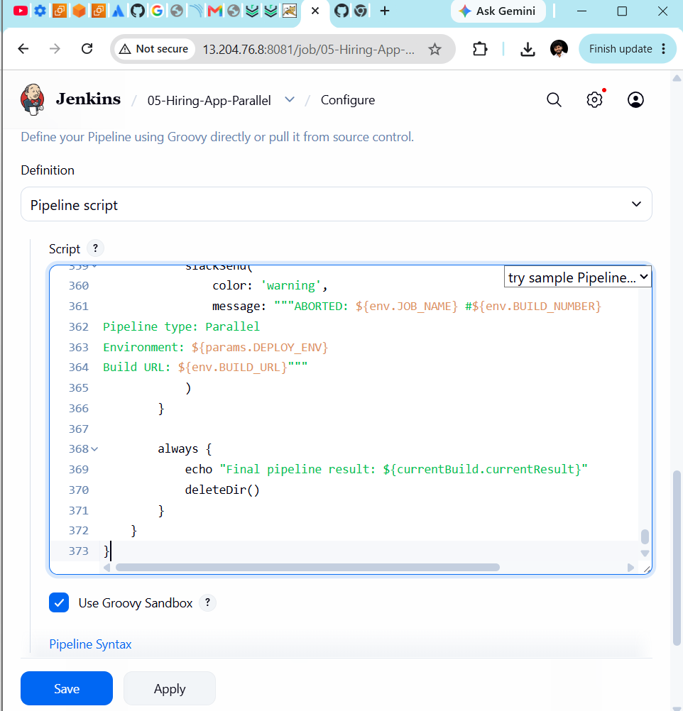
Step 6: Run the pipeline
If the job initially displays Build Now, run it once to register the parameters.
Then select:
Build with Parameters
Use:
DEPLOY_ENV: dev
RUN_SONAR: checked
DEPLOY_APPLICATION: checked
Click Build.
Step 7: Observe the parallel execution
Open:
Build History
→ Latest build
→ Pipeline Overview
Inside Parallel Quality Checks, Jenkins should run these branches concurrently:
SonarQube Analysis
Project Validation
Service Health Checks
Their console lines may appear interleaved. That is normal for parallel execution.
Step 8: Expected result
Expected stages:
Initialize
Workspace Cleanup
Git Checkout
Maven Compilation
Parallel Quality Checks
Maven Package
Archive Artifact
Upload to Nexus
Production Approval — skipped for dev
Deploy to Tomcat
Verify Deployment
Pipeline Summary
Post Actions
Expected final result:
Finished: SUCCESS
